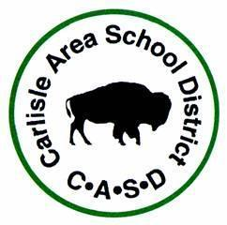
623 West Penn Street
Carlisle, PA 17013

STATEMENT OF JOINT (SHARED) CUSTODY

We, the undersigned parents of: (List Children’s Legal Names)

having no formal or legal agreement to custody rights of the above named children, hereby affirm to the Carlisle Area School District, that a consensual agreement exists for the purpose of having joint (shared) custody. This statement will remain the basis for custody of the children until such future agreements signed and notarized by both parties, or formal legal custody granted through court documents are provided to the District.
Parent/Guardian Name:

Street Address:

City/State/Zip Code:

The undersigned acknowledges that both parents in a shared, or joint, custody arrangement are entitled to access to all of the child’s school and educational records, and to the address of the child and the other parent, unless there is a specific Court Order to the contrary.

Date: ____________________ ___________________________________
Signature of Custodial Father

Date: ____________________ ___________________________________
Signature of Custodial Mother

